DATABASE MANAGEMENT SYSTEMS LAB

NAME-LEPAKSHI JAGMOHAN

SAPID-500119039

RNO-R2142230040

BATCH-2

EXPERIMENT 15

**To understand the concepts of implicit and explicit cursor.**

1. Using implicit cursor update the salary by an increase of 10% for all the records in EMPLOYEES table, and finally display how many records have been updated. If no records exist display the message “**No Change**”.

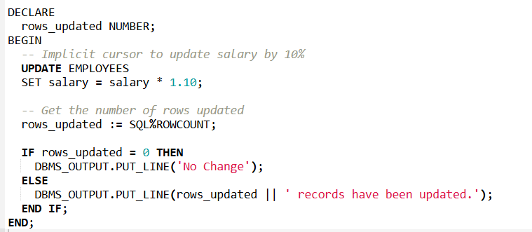

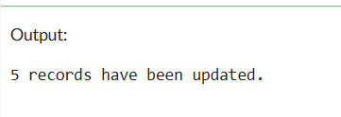

1. Using explicit cursor fetch the employee name, employee_id and salary of all the records from EMPLOYEES table.

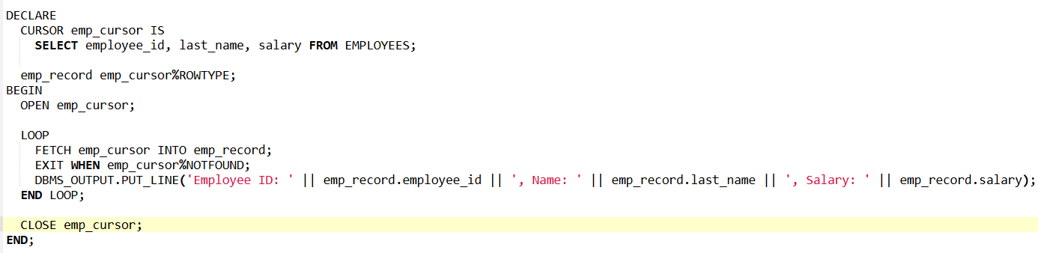

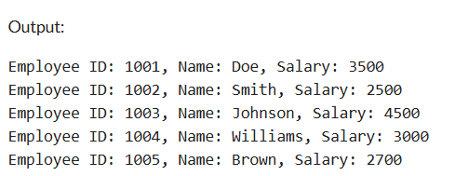

1. Using explicit cursor Insert the records from EMPLOYEES table for the columns employee_id,Last_Name and salary for those records whose salary exceeds 2500 into a new table TEMP_EMP